# **ASSIGNMENT NO-14**

Problem Statement:- **Create an elastic IP for an instance**.

Steps:-

1. **Sign in.** Sign in to your **AWS account.**
2. Create an EC2 instance.
3. Go to **EC2 dashboard** and click on **Elastic IPs.**

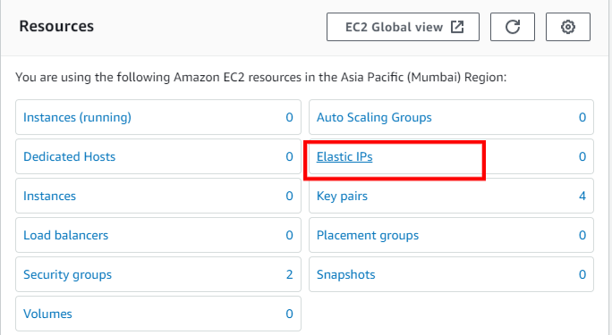

1. Click on **Allocate Elastic IP address**.

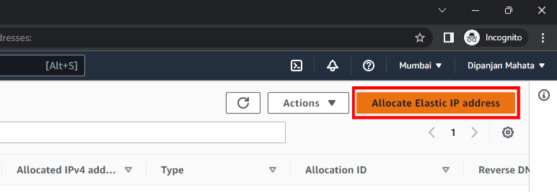

1. Select the **network border group** as same as of you instance and select the **Amazon’s pool of IPv4 address**.

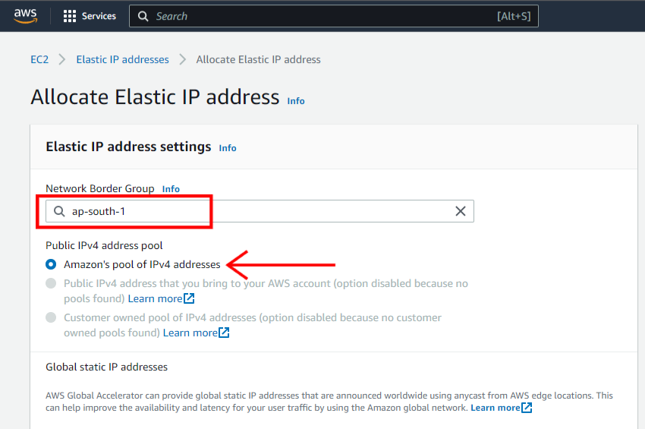

1. Click on **allocate**.

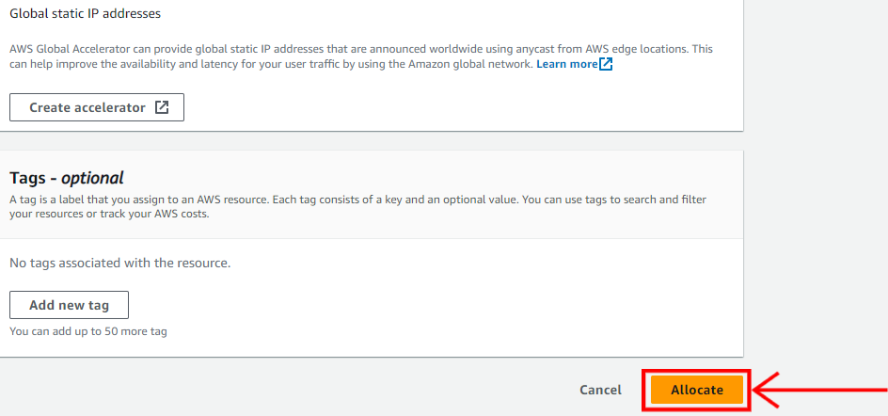

1. Now your Elastic IP address is allocated successfully. Now click on **Associate this Elastic IP address**.

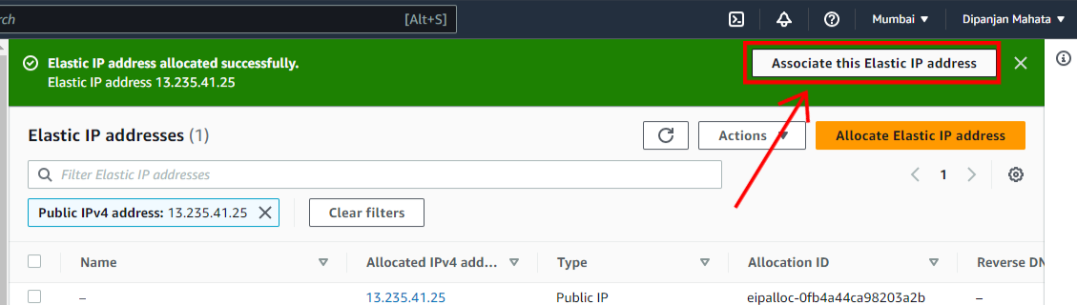

1. Set the **Resource type as Instance**. After that select the **Instance you have created**.

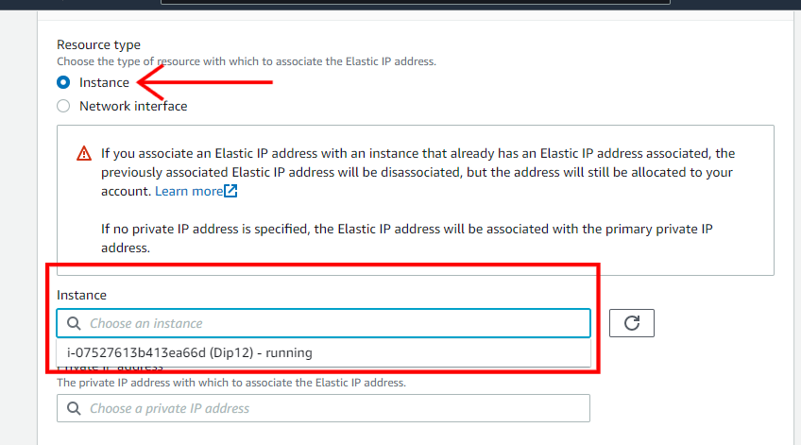

1. After that select the **Private IP address** and click the **check box**. Now click on **Associate**.

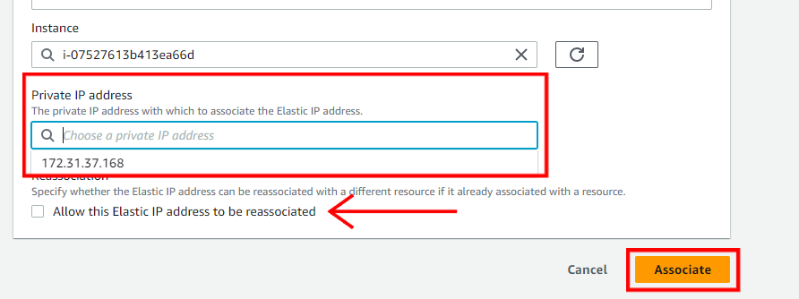

1. Now stop the instance and start it again and you can see the IP does not change and remains the same.

